Principal Component Analysis (PCA)
PCA finds the most important directions in data and removes the rest.
Why Do We Need PCA?
Imagine dataset:
- Height
- Weight
- Age
- Salary
- Experience
- Education
- City
- 50 more columns 😵
👉 Problems:
- Slow training
- Hard to understand
- Some features are duplicate (correlated)

Solution (PCA)
👉 PCA:
- Removes unnecessary features
- Keeps only important information

Simple Real-Life Example
Imagine you take a photo 📷:
- Original = 4K image (very large size)
- Compressed = smaller size but still looks same
👉 PCA works like data compression

Core Idea
👉 Instead of using original features,
we create new features (Principal Components)
These are:
✔ Combination of original features
✔ Capture maximum information
Steps
- Dataset


- Find the Mean
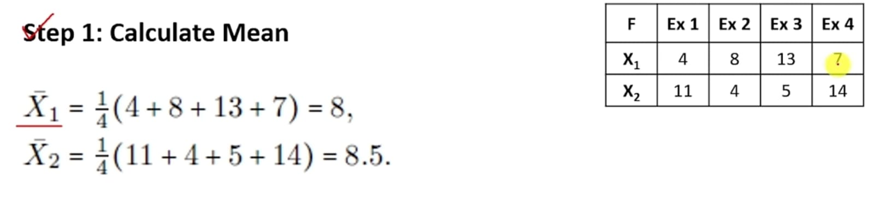
- Find the covariance matrix
Covariance measures relationship between two variables:
- ➕ Positive → both increase together
- ➖ Negative → one increases, other decreases
- 0 → no relationship
👉 Example:
- Height ↑ and Weight ↑ → Positive covariance
- Temperature ↑ and Jacket sales ↓ → Negative covariance

- What is a Covariance Matrix?
- When we have multiple features, we calculate covariance for every pair.
- 👉 Result = Matrix (table of values)

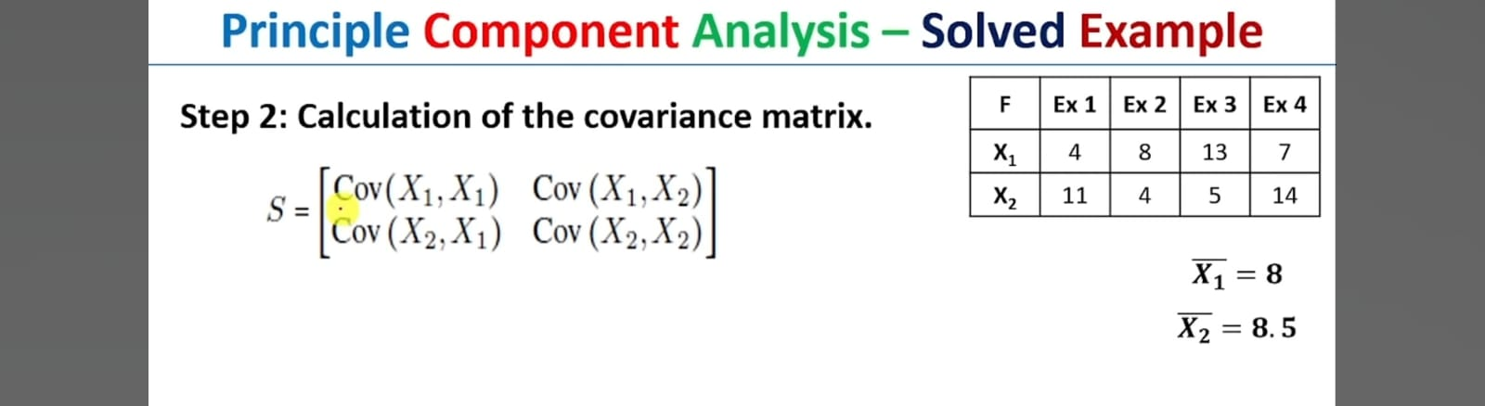

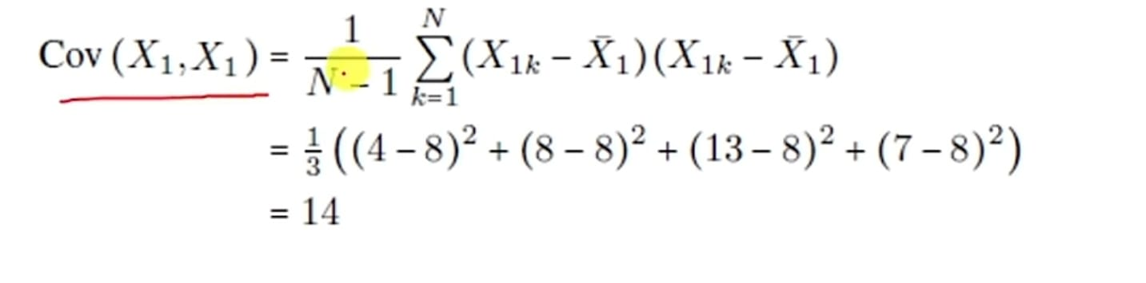
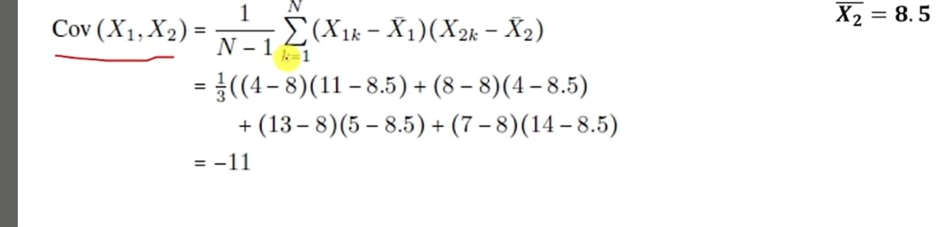

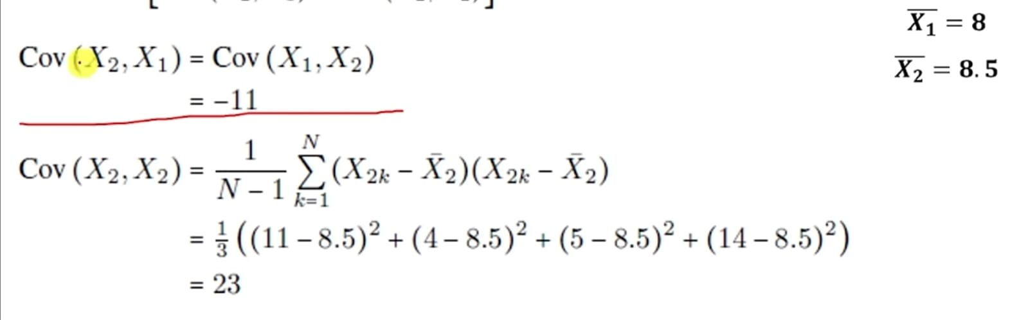

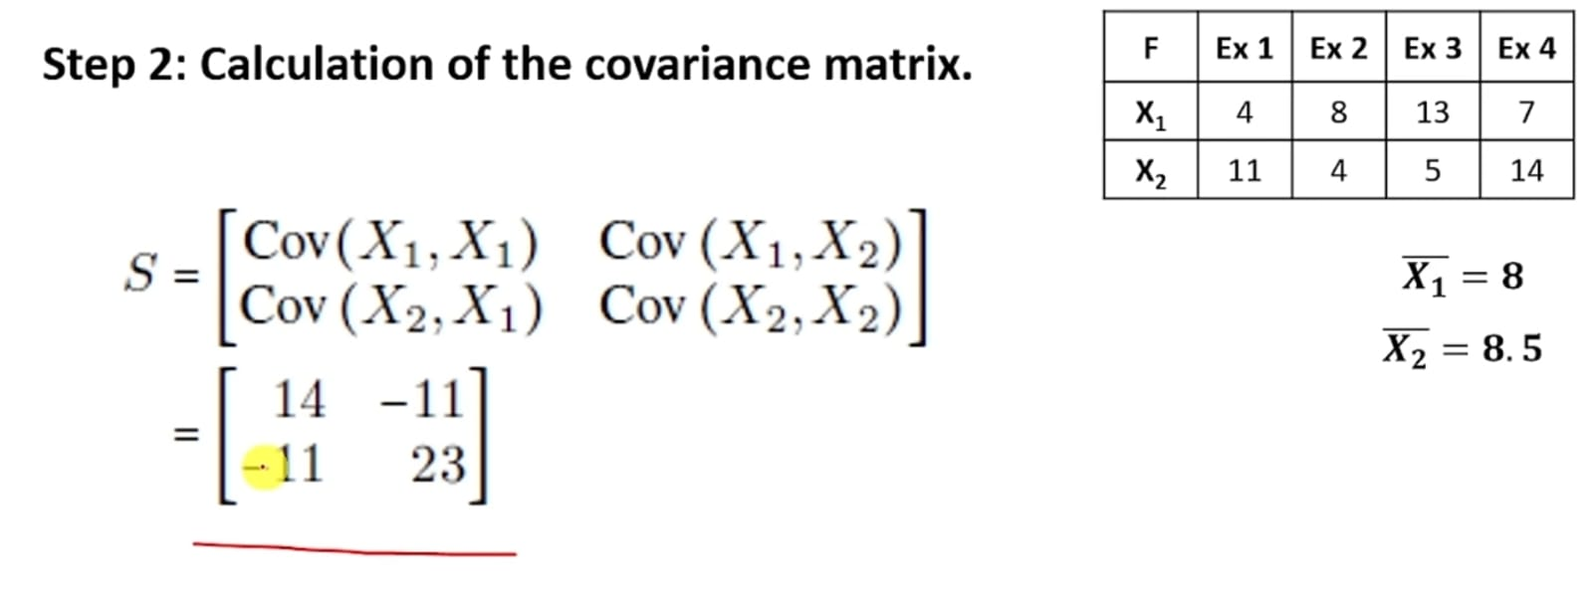

4 Calculate Eigenvalues of the covariant matrix
Eigenvalues tell how much “important variation” exists in a direction
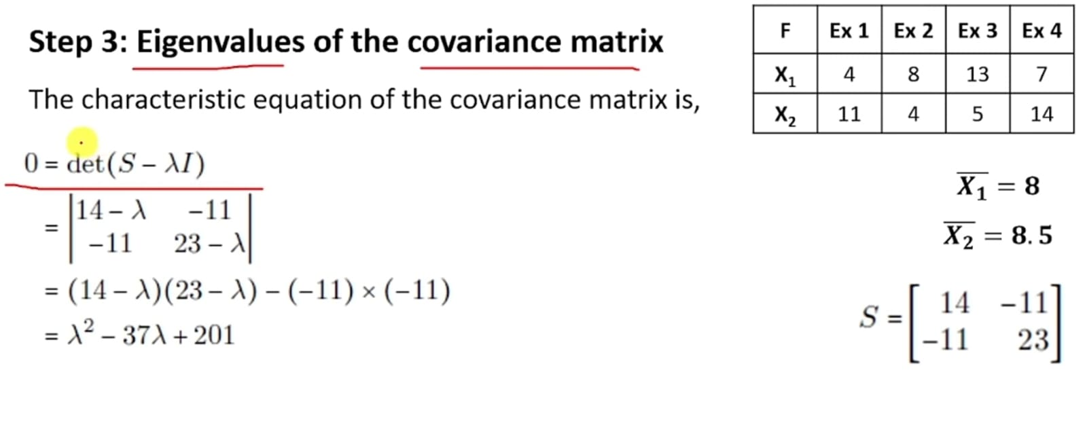
✔ λ₁ ≈ ?
✔ λ₂ ≈ ?

- Calculate Eigen Vectors
Eigenvectors = directions where data naturally spreads
Eigenvector = a direction that does NOT change when we apply a transformation (matrix)
Only the length changes, not the direction.
Imagine:
- You stretch a rubber sheet
- Some directions stay straight (only longer/shorter)
👉 Those special directions = Eigenvectors
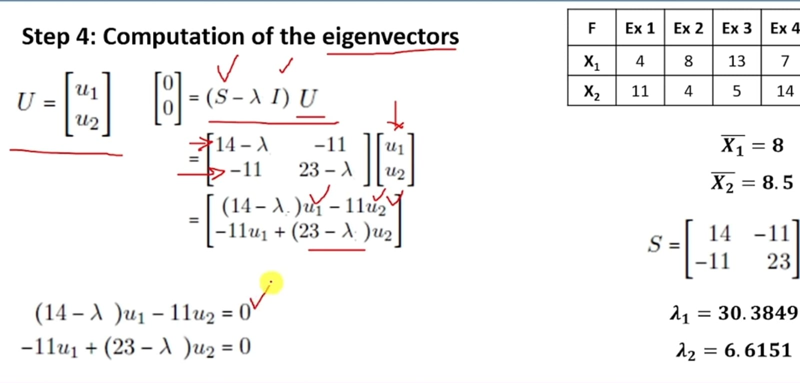

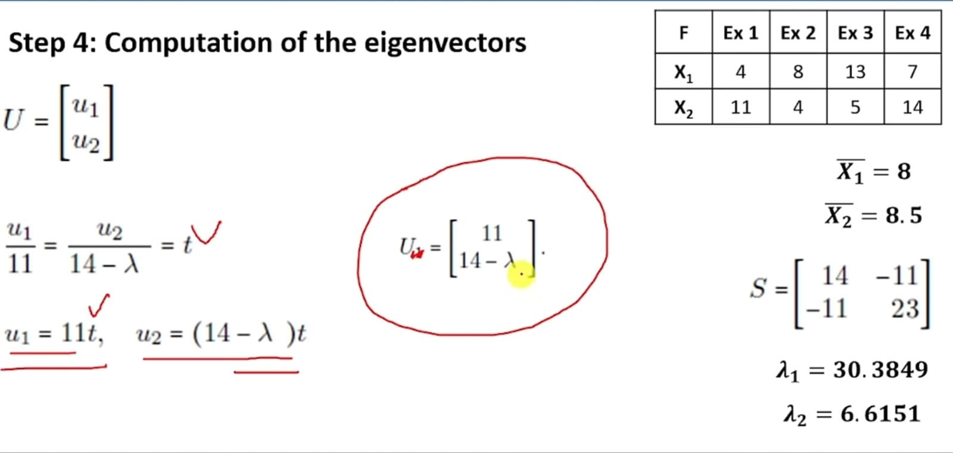

5. Computation of the eigen vectors
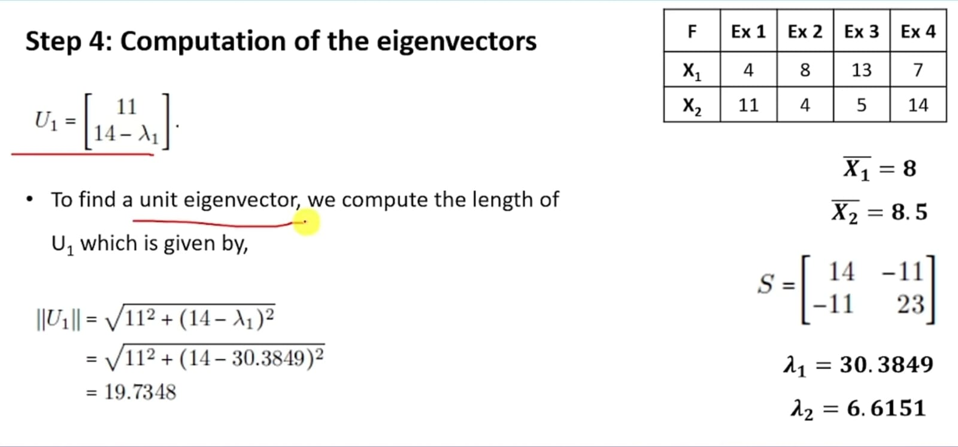
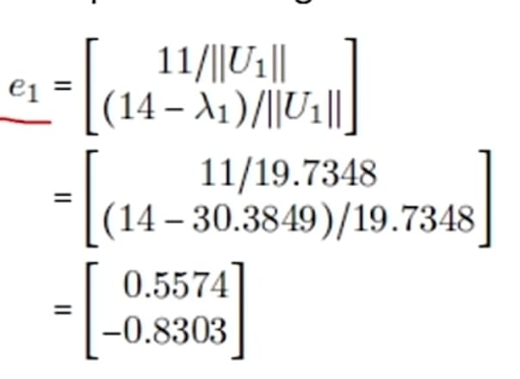
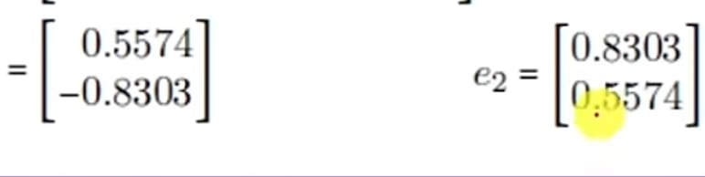
Step 5.
Compute PCA

ˇ

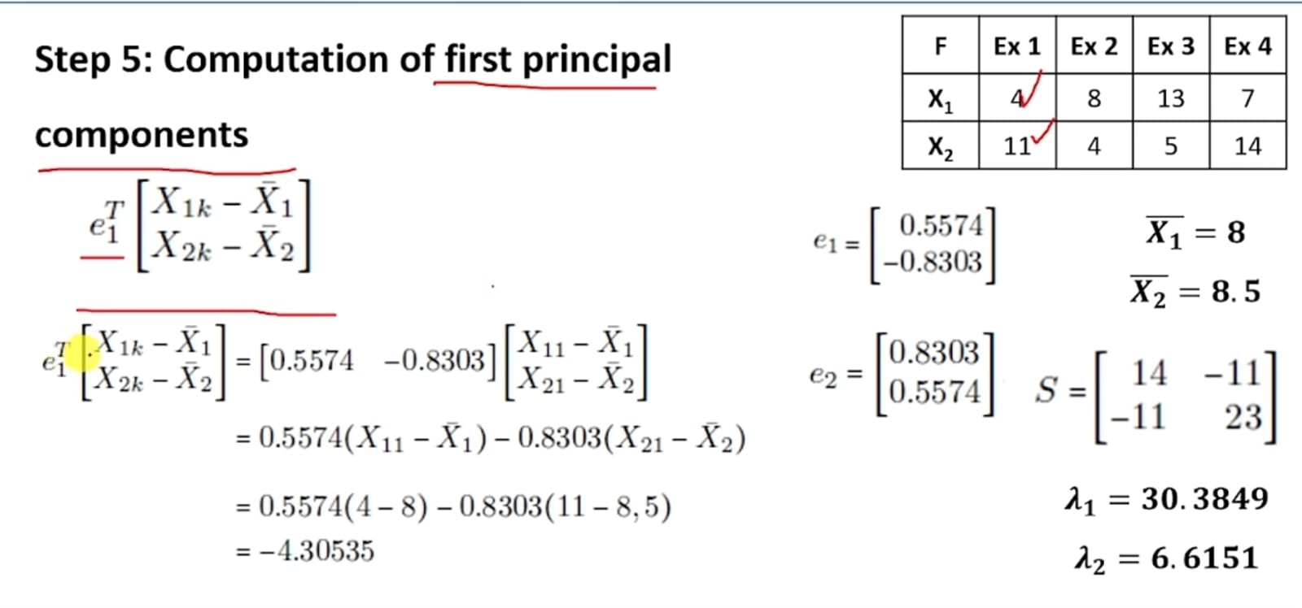

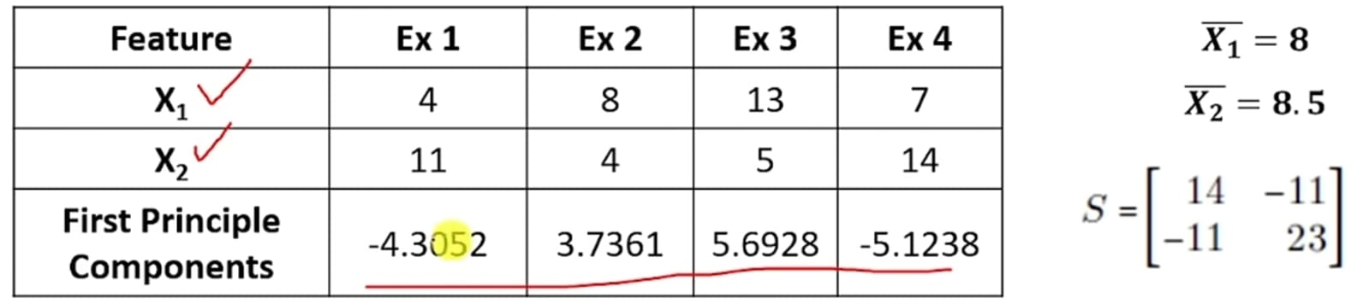

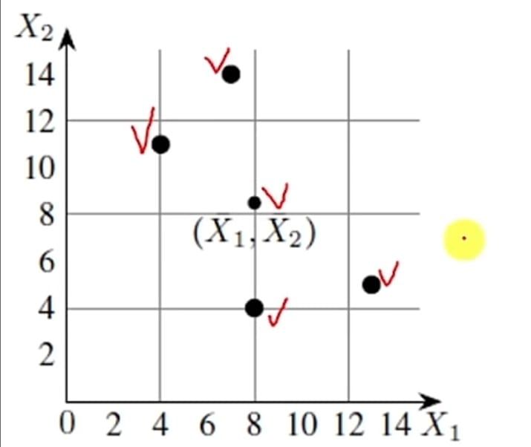

import numpy as np

# -----------------------------
# Step 1: Input Dataset
# -----------------------------
# X1 = [4, 8, 13, 7]
# X2 = [11, 4, 5, 14]

X = np.array([
[4, 11],
[8, 4],
[13, 5],
[7, 14]
], dtype=float)

print("Step 1: Original Data")
print(X)

# -----------------------------
# Step 2: Mean Centering
# -----------------------------
mean = np.mean(X, axis=0)
X_centered = X - mean

print("\nStep 2: Mean of each feature")
print(mean)

print("\nCentered Data (X - mean)")
print(X_centered)

# -----------------------------
# Step 3: Covariance Matrix
# -----------------------------
cov_matrix = np.cov(X_centered, rowvar=False)

print("\nStep 3: Covariance Matrix")
print(cov_matrix)

# -----------------------------
# Step 4: Eigenvalues & Eigenvectors
# -----------------------------
eigen_values, eigen_vectors = np.linalg.eig(cov_matrix)

print("\nStep 4: Eigenvalues")
print(eigen_values)

print("\nEigenvectors")
print(eigen_vectors)

# -----------------------------
# Step 5: Select Top Component
# -----------------------------
# Find index of largest eigenvalue
max_index = np.argmax(eigen_values)

# Select corresponding eigenvector
principal_component = eigen_vectors[:, max_index]

print("\nStep 5: Principal Component (Top Eigenvector)")
print(principal_component)

# -----------------------------
# Step 6: Project Data (Final PCA)
# -----------------------------
X_pca = np.dot(X_centered, principal_component)

print("\nStep 6: Final Reduced Data (1 Feature)")
print(X_pca)

